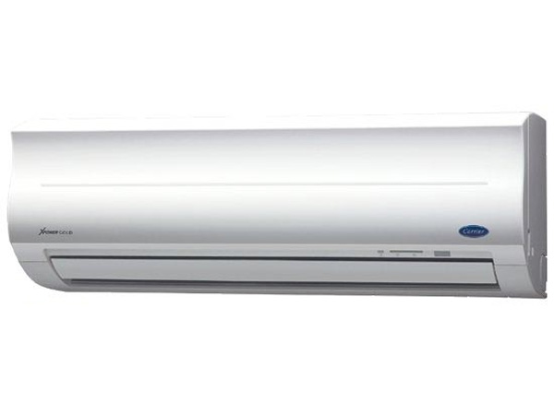

**18.170.000đ**

**Air conditioner Carrier Inverter 38/42 GCVBE 024 24,000BTU Gas R32**

**Specifications**

* Type of air conditioner1 pm
* Usable area30m2 - 40m2
* Installation typeWall mounted
* Inverter technologyHave
* Maximum installation height between hot and cold units15m
* Copper pipe installation length20m
* Voltage source220V/50Hz
* Guarantee24 months
* Made inThailand
* Brand originAmerica

**Indoor unit parameters**

* Size of indoor unitWidth x height x depth *(105cm x 32cm x 25cm)*
* Volume of indoor unit14kg
* Cooling capacity24.000 BTU - 2.5HP

**Outdoor unit parameters**

* Size of outdoor unitWidth x height x depth *(78cm x 55cm x 29cm)*
* Mass of outdoor unit34kg
* Gas usedR32

**Product information**

## Discover Carrier Inverter 38/42 GCVBE 024 air conditioner

**Carrier Inverter 38/42 GCVBE 024** is [a 1-way air conditioner](https://meta.vn/dieu-hoa-1-chieu-c1039)  with a soft, sophisticated design that not only cools effectively but also contributes to the elegance of the room. [Air conditioner with capacity of 2.5HP](https://meta.vn/dieu-hoa-c1018?franges=1.94) is suitable for rooms with an area of ​​over 45m2.

**>> Find out** :  [Which country's Carrier air conditioners and air conditioners are good?](https://meta.vn/huong-dan/tu-van/danh-gia-may-lanh-dieu-hoa-carrier-8980)

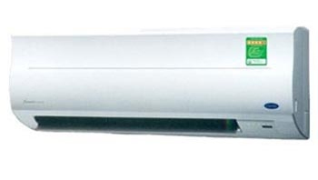

Carrier Inverter air conditioner 38/42 GCVBE 024

Compared to conventional air conditioners, Carrier Inverter 38/42 GCVBE 024 is integrated with Inverter technology, so it saves significant energy during use.

Furthermore, the air conditioner also operates very smoothly and comfortably. The timer feature also helps you and your loved ones have a good night's sleep without worrying about the air conditioner being too cold or forgotten.

[Carrier air conditioner](https://meta.vn/dieu-hoa-c1018?brands=2633) operates durably and has the ability to cool quickly. When it reaches a certain temperature, the air conditioner will maintain and radiate heat as the user desires.

The air conditioner's purifying mode will also bring fresh air. [The air conditioner](https://meta.vn/dieu-hoa-c1018) uses Nano Silver Ginseng and Nano Photo Copper filter technology to effectively prevent bacteria.

**>> See more** :  [How to use the air conditioner control, Carrier air conditioner remote](https://meta.vn/huong-dan/tu-van/cach-su-dung-dieu-khien-dieu-hoa-remote-may-lanh-carrier-9016)

**Note:** Product images are for illustration purposes only, product details, colors, designs and specifications may vary depending on the actual product without prior notice.